Lab 2 Reflection

Proof
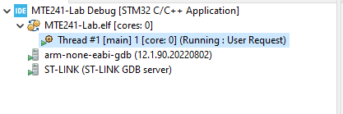
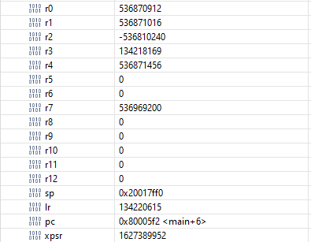

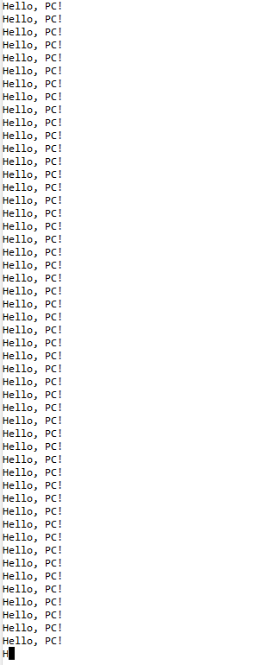

Question 1
In your own words, explain what happened in this lab when you changed PC to hold the function pointer to your print continuously function.

Answer:
When the Program Counter (PC) was changed to hold the function pointer to the print_continuously function, it caused an immediate jump in program execution to that function's memory address. This demonstrates a fundamental principle of computer architecture:The PC register contains the memory address of the next instruction to be executed. By directly modifying PC, we override the normal sequential flow of instructions. Specifically:
- The address of print_continuously was loaded into PC.
- On the next clock cycle, the processor fetched the instruction at that address.
- This caused execution to begin inside the print_continuously function.
- The function's infinite loop then kept updating PC to stay within the function.
This technique, while not used in normal programming, illustrates how operating systems and context switchers can manipulate program flow at a low level.

Question 2
In your own words, explain what a system call is.

Answer:
A system call is a programmatic interface between user-space applications and the privileged kernel-space of an operating system. Key aspects include:
- Purpose: Allows user programs to request services from the OS kernel, such as file I/O, process creation, or network access.
- Protection: Enforces the separation between user and kernel modes, maintaining system security and stability.
- Implementation: Typically involves a special CPU instruction (e.g., SYSCALL on x86) that triggers a switch to kernel mode.
- Handling: The OS kernel maintains a system call table mapping call numbers to handler functions.
- Context Switch: A lightweight context switch occurs, saving user-space state and switching to kernel mode.
- Return: After servicing the request, the OS returns control to user-space, often with a return value or error code.
System calls are fundamental to the operation of modern operating systems, providing a controlled interface for applications to interact with hardware and protected system resources.

Question 3
Explain in your own words how the thread’s stack was set up. Comment on what it means to “set up a thread’s stack”, and why we need to store register values on the stack.

Answer:
Setting up a thread's stack involves several key steps:
- Memory Allocation: A contiguous block of memory is reserved for the stack.
- Stack Pointer Initialization: The stack pointer (SP) is set to the top of this allocated memory.
- Context Preparation: Initial register values are pushed onto the stack in a specific order, creating a "fake" context as if the thread had been running before.
Key register values stored typically include:
- General-purpose registers (R0-R12 on ARM)
- Link Register (LR) for return address
- Program Counter (PC) set to the thread's entry point
- Program Status Register (PSR) for flags and execution state
Storing register values on the stack is crucial because:
- It preserves the thread's execution context.
- It allows for easy context switching by simply changing the stack pointer.
- When the thread is scheduled to run, these values can be popped off the stack to restore its state.
This process is fundamental to multitasking operating systems, enabling the illusion of concurrent execution on a single-core processor.

Question 4
In the switch/case in SVC_Handler_Main, we set PSP using the __set_PSP function before we could run the thread. If we didn’t do this, the code would crash in a hard fault. Explain why.

Answer:
Setting the Process Stack Pointer (PSP) before running a thread is critical for several reasons:
- Memory Isolation: Each thread needs its own stack to maintain separation between threads' local variables and call frames.
- Context Switching: The PSP is part of the thread's context, allowing the OS to switch between threads by changing stack pointers.
- Exception Handling: Many processors use the current stack pointer for exception handling. An invalid PSP could lead to corruption during interrupts or exceptions.
- Stack Operations: Push and pop instructions implicitly use the current stack pointer. An uninitialized PSP would cause these operations to access invalid memory.
If PSP wasn't set:
- Stack operations would occur at an undefined memory location.
- This would likely cause memory corruption or access violations.
- When an exception occurred (e.g., to handle a system call), the processor would try to push state onto an invalid stack.
- This invalid memory access would trigger a hard fault, causing the system to crash.
Properly setting PSP ensures that each thread has a valid, isolated stack space, which is fundamental to the stable operation of a multithreaded system.

Question 5
Our thread function looped continuously. Assume that it didn’t, and instead it simply printed something once and returned. What would happen?

Answer:
If the thread function printed once and returned instead of looping continuously, several issues would arise:
- Stack Unwinding: The function's return would attempt to pop the return address from the stack. However, this address was artificially placed there during thread creation and doesn't represent a valid caller.
- Execution Flow: After popping this invalid return address, the processor would attempt to continue execution at an unpredictable location, likely causing a crash.
- Resource Leakage: Any resources allocated to the thread (e.g., its stack memory) would not be properly released, potentially causing memory leaks.
- Scheduler Issues: The operating system's scheduler would not be aware that the thread had completed, potentially leading to attempts to schedule a non-existent thread.
- System Instability: Without proper thread termination handling, the system could enter an undefined state, potentially affecting other threads or the entire system.
To handle this scenario properly, an operating system typically needs:
- A mechanism for threads to signal completion.
- A thread exit system call to properly clean up resources.
- Scheduler logic to remove terminated threads from the ready queue.
- Potentially, a "join" mechanism for other threads to wait for and detect thread completion.
This scenario underscores the importance of proper thread lifecycle management in a multitasking operating system.

Grading
Each question is evaluated based on the following scale.
Meets expectations: The answer is entirely correct. The answer is sufficiently detailed to include the major ideas necessary to prove that the student understands the concept. The answer is clear.
Approaching expectations: The answer contains no incorrect statements, but requires more detail or is too vague to convince the grader that the student understands the concept. The answer is clear.
Does not meet expectations: The answer either contains some incorrect statements or lacks detail to the degree that major portions of the question are left unanswered. The answer is not clear.
Not observed: the answer is largely incorrect or absent.
To get a grade for a question, you must obtain a rating of “meets expectations” on that question. You may resubmit as many times you like until you achieve that rating.

